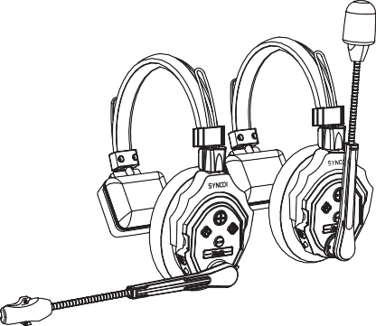

F**X**u**T**ll **A**Du**L**p**K**lex Wireless Intercom Headset System

User Manual

TcahraenfuklylyobueffoorrcehuosoesainngdSfoYNlloCwO aplrloindsutcrtu.cPtlioeanssemreeandtiothniesdmhaenrueainl.

**· C**Pl**a**ea**r**s**i**e**n**k**g**eep**F**t**o**he**r**p**Y**ro**o**d**u**uc**r**t in**S**a**Y**d**N**ry**C**, c**O**lean**P**, **r**du**o**s**d**t-f**u**re**c**e **t**environment.

**·**proKdeuepctctoorproresivveencthmemecihcansi,claiql udiadms agned. heat sources away from the

* Use only a soft and dry cloth for cleaning the product.
* Malfunction may be caused by dropping, the impact of external force.
* Do not attempt to disassemble the product. Doing so voids the warranty.

**·**

tecPhlenaicsieanhsavifeatnhyempraolfduuncctticohneschkeadppoernre. paired by authorized

* Failure to follow all the instructions may result in mechanical damage.
* Warranty does not apply to human errors.

# Packing List

(3/5 pHcesafdosreXt3/X5)



Storage Bag x1

(2/3 pcCsafbolreX3/X5) Re(3c/h5aprgcesafbolreXB3a/Xtt5e)ry (5M/8icpWcsinfodrshXi3e/lXd5)

(C2/h3aprgcisnfgoSr tXa3t/ioXn5)



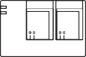One(5-/E8arpFcos afomr XC3u/sXh5i)ons

# Product Introduction

① 3.5mm Mic In Port

② Power On/Off Toggle

③ Indicator Light

④ Button A

⑤ Volume ＋

⑥ Button B

⑦ Volume －

⑧ Type-C Port

1. **OPpoweerraOtni/oOnffs**

Power On: Push the power toggle switch upwards to turn it on.

Power Off: Push the power toggle switch downwards to turn it off.

## Master/Remote Settings

Tseocsoentd/csa. nEcveelrtyhheehaedasdest eistsaavsaitlhaeblMe atostbere, sloent ga-spMreassstethr/eRAembuotteo.n for 8

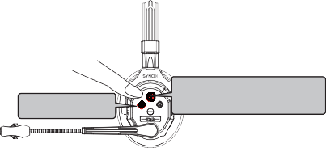*ReLmonogtepmreossdtehveovicoelupmroemuptb. utton for 3 seconds to play the Master/

Set as Master

PlaoydethveoMicaespteror/mRepmt. ote

1. **Pairing** Long press the A key for 3 seconds to enter pairing mode. Long press the A key for 3 seconds to cancel pairing.

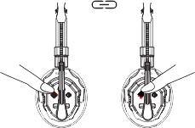

## Volume Settings

vSohlourmt per.ess the volume up/down button to increase/decrease the

## Noise Cancellation

Short press the B button to turn on/off the noise cancellation feature.

## Mute/Unmute

R* oTthaeteMtuhteeb/Uonomuatremmuopd/edovowince(spereomthpetpwicitllubre bpelaloyewd) toonmceutthee/uMnumteu/te.

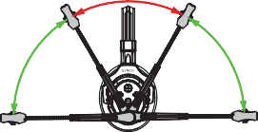Unmute is activated.

Mute

Unmute Unmute

## Domination Mode

RPeremssotaensd. ThhoeldRtehmeoBtebsuattroensttioll eanvtaeilradbolemfionraltiisotennminogdaenfdorthmeuMtiansgtearllis

available for speaking. Release to exit domination mode.

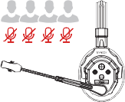

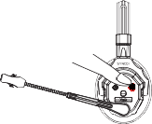

## Indicator Light Status

Green Light Flashing Green Light Steady Red Light Flashing Red Light Steady

## Powering

Not Connected Connected Low Battery Charging

1. Via Replaceable Battery Power

Poutswhadrodwton pthlaecteo/gregmleoovfeththeebbaattteteryryc.ase then pull the case door

1. Via Power Bank

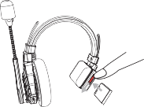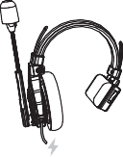Use the Type-C port for simultaneous charging and using.

## Real-Time Monitoring

tChoenanuedctiothfreodmevdiecveiscew.ith headset via 3.5mm TRS port for monitoring

|  |  |
| --- | --- |
|  | |
| TWriarnelsemssisTseiocnhnMoolodgey  Operating Range | Duiglli-tDalu2p.l4eGxHz  350m (LOS) |
| Frequency Band | 2.4GHz |
|  | |
| Approximate RF Sensitivity | <-90dBm |
|  | |
| BPoatwterry Capacity 1U0S5B0-mC A5hVLi-ion Battery | |
|  | |
| WChoarrkgininggTTimimee 2A0bHout 2.5H | |
|  | |
| Frequency Re ponse | 150Hz~7KHz |
|  | |
| DMiisctroorptihoonne Type <C1on%denser Microphone | |
|  | |
| OMuatxpIuntpSuot uSnodunPdrePsrseusrseuLrevLeelvel T>1yp15icdaBl S9P8+L3dBSPL(at 94dBSPL 1KHz) | |
|  | |
| TWeemigphetrature Range A0~b+o4u5t°1C8(8Wgo（rkBiantgteSrtyaItnucsl）uded） | |
|  | |
| -20~+60° C(Storage Condition) | |

**WWarrAaRntRy PAeNrioTdY**

Thank you for purchasing SYNCO products.

1q.uCaulistytodmeefercsta(sr)efeonutnitdleind tohefrpereordeupclat cuenmdernnt ormreaplauisresewrivtihcieni3n0cdasaeysof s2e. rOvriicgei.nTahl SeYwNaCrOrapnrtoy dpuecritosdarbeeegnintistloendtthoe1d2a-mteoonftphulrimchitaesde wofabrrrantdy

upon receipt of the product.

new, unused products by the first end-user.

mWiattheirniatlhdeewfeacrtriaonntyorpteerciohdn,oilfopgriocdaul pctrodbelfeemct,othr efadileufreecitsivaettprirboudtuacbtleorto mdeafteecrtiiavles pfeaer)t.will be repaired or replaced without charge (service and

## Warranty Exclusions and Limitations

1it.sFoapueltrsatrieosnulstpeedcfirfiocmationnappropriate use of a product without following

2. Artificial damage, e.g. crash, squeeze, scratch, or soaking 3w.rMittoednificcoantsioents otof SaYpNrCoOdu, ec.tgb. yreitpslaucseemr oernat othf ierdlempaerntyt woritchirocuutitp,rliaobrel

alteration

o4.rTthe code on tphreodpurocdt uiscitnocrownsairsrtaenttywciethrtitfihcaattoefiws alrtrearnetdy ocrerttoirfincaotffe, m5. uAffll,cboanttseurmy able accessory attached to a product, like cable, wind

6. Faults as a result of force majeure, such as fire, flood, lightning, etc.

## Warranty Claim Procedure

c1o. Inftfaaciltuareloocraal naygepnrot bfoler massoicsctaunrsceto, oyroyuorupcroadnuacltwaafytesrcpounrtcahctasSeY,NpCleOa’ses

customer service through email at [support@syncoaudio.com.](mailto:support@syncoaudio.com)

2. Please retain your sales receipt and warranty certificate as proof of

pchuarcrgheaasbe.leIfsaenryviocef twhiellsebedopcrouvmideendts. is missing, only sales return or t3h. eIf pthaertSs YcNosCtOwpilrlobdeuccht aisrgoeudt.of the warranty coverage, the service and

Guangzhou Zhiying Technology Co., Ltd RDoisotrmict2,4G0u1a, n2g4z/hFo, uS,oCuhthinTao, 5w1e0r0, L0i0sheng Plaza, No. 68 Huadi Avenue, Liwan [swuwpwpo.srytn@csoyanucdoiaou.cdnio.com](mailto:swuwpwpo.srytn@csoyanucdoiaou.cdnio.com)